Ch3 Nature’s Trail
National parks and biosphere reserves are like super- safe, protected homes for wild plants and animals they help keep nature healthy and ensure that rare animals don't disappear from our planet
Q1.Importance of National Parks and Biosphere Reserve
Ans-1. They protect wild animals and plants.
2. They help conserve endangered species.
3. They maintain the balance of nature.
4. They preserve forests and natural habitats.
5. They support scientific research and education.
6. They promote the sustainable use of natural resources.
Biosphere Reserve | State / U.T.
- Nilgiri | 1.Tamil Nadu
- Similipal | 2.Odisha
- Pachmarhi | 3.Madhya Pradesh
- Dehang-Dibang | 4.Arunachal Pradesh
- Great Nicobar | 5.Nicobar Island

National Park | State | Famous Animal
1.Kaziranga | 1.Assam | 1.One-horned Rhino
2.Sundarban | 2.West Bengal | 2.Royal Bengal Tiger
3.Gir | 3.Gujarat | 3.Asiatic Lion
4.Jim Corbett | 4.Uttarakhand | 4.Royal Bengal Tiger
5.Periyar | 5.Kerala | 5.Asian Elephant

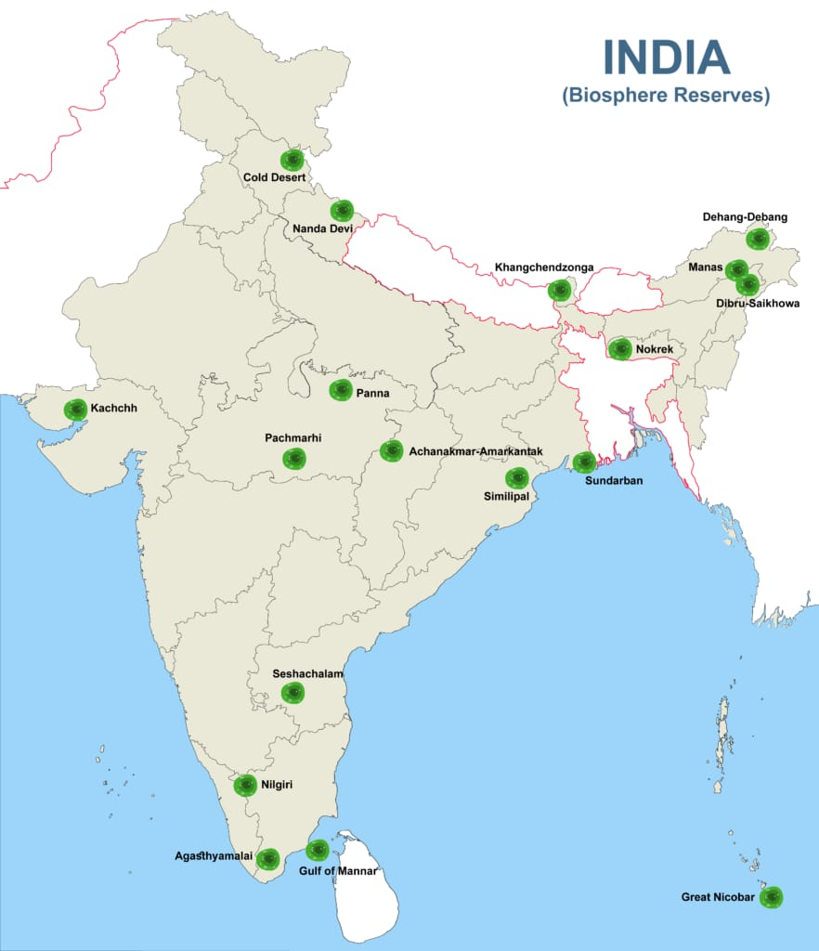

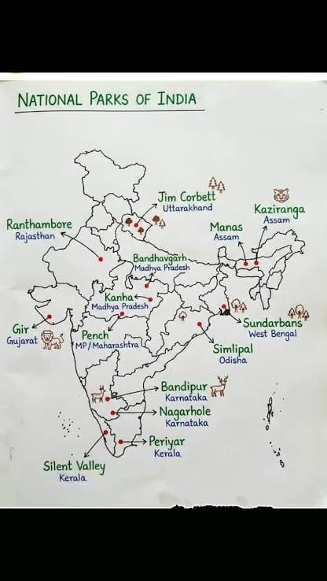

Q2. Extinct animals: Animals that no longer exist. Eg- Dodo bird
Q3. Endangered animals: Animals that may disappear in the future if they are not protected. Eg- Bengal Tiger
Q.4 Q.Reasons why animals are getting endangered and extinct.
Ans- a. Habitat loss
b. Hunting
c. Pollution
d. Climate change
e. Deforestation
f. Forest fires
g. Human activities
Q5. Spectacled Monkey- Pg 41
Q6.The Indian Giant Squirrel
It is a large, colorful squirrel that lives in trees. It has a long bushy tail and feeds on fruits, nuts, seeds, and leaves.1
Q7.Importance of Beaks
Ans-1.Beaks help birds pick up and eat food.
2.They help birds tear, crack, or catch food.
3.Birds use their beaks to build nests and feed their young.
Q8.Importance of Claws
Ans-1. Grip branches and perch on trees.
2. Catch and hold food.
3. Protect themselves from enemies.
Q9.Aquatic Animals- Pg-48
Gills help aquatic animals breathe underwater.
Q10.Amphibians
Amphibians are animals that can live both on land and in water.
Q11. Name some amphibians .
Ans- Frog, Toad, Salamander
Q12. Insects- Pg- 49
Q13. Name some insects.
Ans-
Q14.A food chain is a sequence that shows how food and energy pass from one living thing to another.
Eg.
Grass → Grasshopper → Frog → Snake → Eagle
Q15.Food Web
It is a group of interconnected food chains. It shows the feeding relationships among living things and helps maintain the balance of nature.

